# **Tasks**

**Learners have to develop a dashboard to support the answers to the following questions and suggestions for places for newer restaurants.**

**Objective Questions**:

1. What is the total no. of tables present in the data?

**Ans:** 2 Tables are present in the dataset. Raw data and Country description.

1. What is the total no. of attributes present in the data

Ans. There are two tables present in the data. 1st table Raw data’s Attributes are as follows:

• **RestaurantID**: Unique identifier for each restaurant.

• **RestaurantName**: Name of the restaurant.

• **CountryCode**: Code representing the country of the restaurant.

• **City**: City where the restaurant is located.

• **Address**: Full address of the restaurant.

• **Locality**: Local area or neighbourhood of the restaurant.

• **LocalityVerbose**: Detailed description of the locality.

• **Longitude**: Geographical longitude of the restaurant.

• **Latitude**: Geographical latitude of the restaurant.

• **Cuisines**: Type of cuisines offered by the restaurant.

• **Currency**: Currency used for transactions at the restaurant.

• **Has_Table_booking**: Indicates whether the restaurant offers table booking (Yes/No).

• **Has_Online_delivery**: Indicates if the restaurant provides online delivery (Yes/No).

• **Is_delivering_now**: Indicates whether the restaurant is delivering at the current time (Yes/No).

• **Switch_to_order_menu**: Indicates if the menu is switched to an order-based menu (Yes/No).

• **Price_range**: Price category of the restaurant, on a scale from low to high.

• **Votes**: Number of votes received by the restaurant.

• **Average_Cost_for_two**: Average cost for two people dining at the restaurant.

• **Rating**: Restaurant rating based on customer feedback.

• **Datekey_Opening**: Opening date of the restaurant in the format YYYY_MM_DD.

2nd table has Two attributes

* Country Code and Country Name

1. How many categorical columns are there in the data? [Search about categorical and continuous data, and try to answer this question]

Ans. Categorical Columns are those which don’t have numerical data in it such as Binary numbers etc but has text data and there are 12 categorical columns in the data in the sheet Raw Data and they are:-

* **Categorical Columns**:
* RestaurantName, CountryCode, City, Address, Locality, LocalityVerbose, Cuisines, Currency, Has_Table_booking, Has_Online_delivery, Is_delivering_now, Switch_to_order_menu.
* **Continuous Columns**:
* RestaurantID, Longitude, Latitude, Price_range, Votes, Average_Cost_for_two, Rating, Datekey_Opening.

There is only one categorical column In the Country Description Sheet and that is Country name.

1. The data consists of some inconsistent and missing values so ensure that the data used for further analysis is cleaned.

Ans.Cleaning steps I used for the data

* Deleted 9 rows of cuisines of cities like as the data was not available.
* Took the average of prices for two and filled which were blanks.
* Took the average of longitude and filled the blanks.
* Extracted Year From Datekey_opening
* Converted Average Cost for two in rs so that it would be easy in calculation
* Made a column Name filtered Rating.

1. Using the LookUp functions, fill up the countries in the original data using the country code.

Ans. I’ve used Vlookup to add countries in the original data. 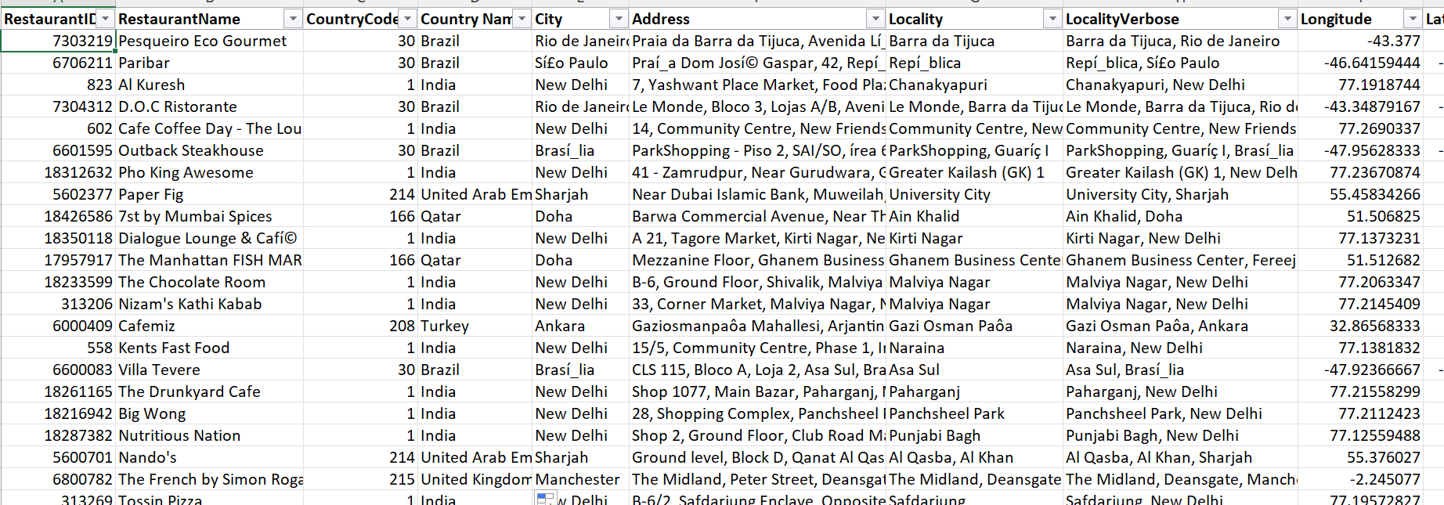

1. Create a table to represent the number of restaurants opened in each country.

Ans. I’ve Created a Pivot Table that shows restaurants opened In each country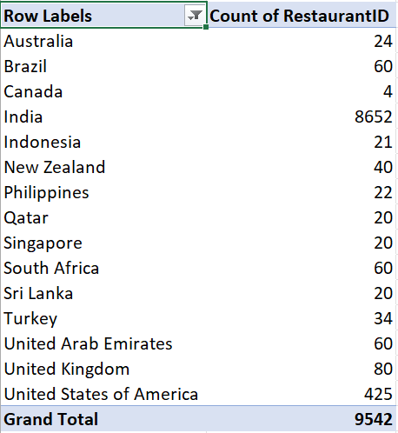

1. Also, the management wants to look at the number of restaurants opened each year, so provide them with something here.

Ans.I have created a pivot table that’s shows No. of Restaurants Opened Each year. 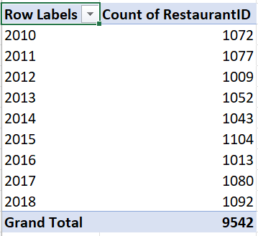

1. What is the total number of restaurants in India in the price range of 4?

Ans. Filtered the RestaurantID to1 and Price Range of 4. Total no. is 388

1. What is the average number of voters for the restaurants in each country according to the data?

Ans. 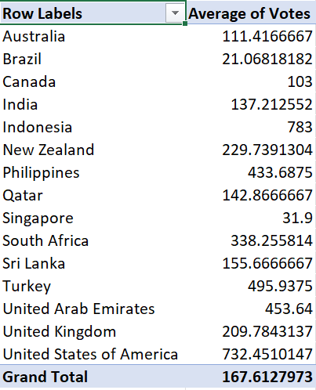

1. Calculate the average rating for all the restaurants that have price_range < 4 and provide online delivery. Use only the “IF” function, Logical Operators, and Aggregation functions to solve this problem. **[Note: Don’t use Conditional aggregation in this question.]**

Ans. Did it using IF function , And function.

1. Created a column As “Filtered Rating” using formula

=IF(AND(Q2 < 4, N2 = "Yes"), T2, "")

1. Then Found Average of the Row

Average = 3.27381151

**Sheet raw data**



1. Using Conditional formatting highlight the rows of restaurants that are located in the countries or cities that you’ve suggested to the management for opening new restaurants.

Ans. Using Conditional Formatting I have highlight the rows of seven countries that I have suggested named: Australia, Canada, Singapore, Sri Lanka, Indonesia, Phillipines, Qatar

* In Conditional Formatting go to new new rule, click on “ Use a formula to determine which cells to format”.
* In formula field entered the formula

=$D2= “Sri Lanka”

=$D2= “Singapore”

=$D2= “Canada”

* =$D2= “Australia”  
    
  **Present In the Sheet Raw Data**

1. Create a new customized price column that consists of the abbreviation/symbol of the currency along with the Average_cost_for_two value. [Use string operations to do this task]

Ans: I have used Mid, Find Function  
 =MID(L2, FIND("(",L2)+1,FIND(")",L2)- FIND("(",L2)-1) & " " & S2

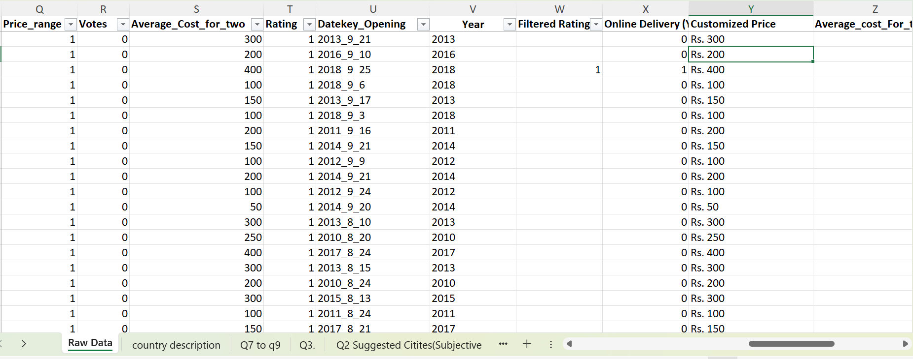

**Sheet Raw Data Column (Y)**

1. How can you create an array formula in Excel or Google Sheets to count the number of restaurants listed that do not offer online delivery, are in the lowest price range, and have an average cost for two people less than or equal to 250 Indian Rupees?

Ans. = COUNTIFS($N$2:$N$9543,"No",$Q$2:$Q$9543,"1",$AA$2:$AA$9543,"<=250")

**Sheet Raw Data**

**Subjective Question:**

1. Suggest a few countries where the team can open newer restaurants with lesser competition. Which visualization/technique will you use here to justify the suggestions?

Ans. **Approach**-: I have used pivot table to analyse the Data and the count of No. of restaurants opened in each countries and also the Average Rating .

Based on that I have used a line chart As visualization technique to Show it.

Countries like-:

* Canada
* Qatar
* Singapore
* Sri Lanka

**Recommendation:**

* It is suggested to open new restaurants in the below countries
  + - Canada
    - Qatar
    - Singapore
    - Sri Lanka
* As these countries has lesser number of restaurants and lower ratings, the competition will be lesser and focus on improving quality of food and service to improve customer satisfaction for higher ratings.

|  |  |  |  |  |  |  |  |  |  |  |  |  |  |  |  |  |  |  |  |  |  |  |  |  |  |  |  |  |  |  |  |  |  |  |  |  |  |  |  |  |  |  |  |  |  |  |  |  |  |  |
| --- | --- | --- | --- | --- | --- | --- | --- | --- | --- | --- | --- | --- | --- | --- | --- | --- | --- | --- | --- | --- | --- | --- | --- | --- | --- | --- | --- | --- | --- | --- | --- | --- | --- | --- | --- | --- | --- | --- | --- | --- | --- | --- | --- | --- | --- | --- | --- | --- | --- | --- |
| |  |  |  | | --- | --- | --- | | **Row Labels** | **Count of RestaurantID** | **Average of Rating** | | Canada | 4 | 3.575 | | Qatar | 20 | 4.06 | | Singapore | 20 | 3.575 | | Sri Lanka | 20 | 3.87 | | Indonesia | 21 | 4.295238095 | | Philippines | 22 | 4.468181818 | | Australia | 24 | 3.658333333 | | Turkey | 34 | 4.3 | | New Zealand | 40 | 4.2625 | | Brazil | 60 | 3.846666667 | | United Arab Emirates | 60 | 4.233333333 | | South Africa | 60 | 4.21 | | United Kingdom | 80 | 4.1 | | United States of America | 425 | 4.014352941 | | India | 8652 | 2.770550162 | |  |  |
|  |  |  |
|  |  |  |
|  |  |  |
|  |  |  |

**Sheet subjective question**

1. Come up with the names of States and cities in the suggested countries suitable for opening restaurants.

Ans. **Approach**

I have counted city wise restaurants. I have used pie Chart to Visualize the data .Cities which have less that 20 restaurants , Zomato can open new restaurants in those cities .

* To list down the city names for suggested countries, create a pivot table with🡪 Country + City in Rows 🡪 Count of restaurants + Average ratings in Values 🡪 Filter on country with the 4 recommended countries (Canada, Qatar, Singapore and Sri Lanka) selected.

**Insight:**

* From the pivot table, we can see that Canada while having the lowest number of restaurants, the cities Consort and Yorkton have the lowest average ratings.
* Singapore, Qatar and Sri Lanka have their restaurants in only one city.
* Singapore although having the same number of restaurants as Sri Lanka is still lower in terms of average ratings.

**Recommendation:**

* It is suggested to open new restaurants in the below cities
  + - Consort
    - Yorkton
    - Singapore
    - Colombo
* Consort and Yorkton in Canada provide an optimal environment for opening of a new restaurant as they both have only one restaurant under Zomato and also has the lowest average rating among others.
* Singapore has 20 restaurants with an average of 3.6 ratings. Focus on quality of food and providing good customer services should also be given when opening a new restaurant.
* Colombo, Sri Lanka also has 20 restaurants in total with ratings of 3.9.
* Opening new restaurants in these locations would be a great opportunity as there will be low competition and managers can focus more on the customer satisfaction and quality.

|  |  |  |
| --- | --- | --- |
| **Row Labels** | **Count of RestaurantID** | **Average of Rating** |
| **Canada** | **4** | **3.575** |
| Chatham-Kent | 1 | 3.7 |
| Consort | 1 | 3 |
| Vineland Station | 1 | 4.3 |
| Yorkton | 1 | 3.3 |
| **Singapore** | **20** | **3.575** |
| Singapore | 20 | 3.575 |
| **Sri Lanka** | **20** | **3.87** |
| Colombo | 20 | 3.87 |
| **Qatar** | **20** | **4.06** |
| Doha | 20 | 4.06 |

* **sheet subjective question**

1. According to the countries you suggested, what is the current quality regarding ratings for restaurants that are open there?

Ans. **Approach:**

* Since ratings are a key performance metric, we analyzed locations by including both the average ratings and the number of restaurants to identify suitable spots for new restaurant ventures.
* The Pivot Table displays **Country + City** in the Rows and **Count of Restaurants + Average Ratings** in the Values, filtered for the selected countries: **Canada, Qatar, Singapore, and Sri Lanka.**

**Insight:**

* Canada and Singapore both have an average rating of **3.6**, while Sri Lanka stands at **3.9** and Qatar at **4.1.**
* Despite having the same number of restaurants as Sri Lanka, Singapore's average rating is lower.

**Recommendation:**

* **Canada:** Cities like Consort and Yorkton show average ratings below **4.0**, making them promising areas for opening new restaurants. Improving food quality and service here could enhance customer satisfaction and ratings.
* **Singapore & Sri Lanka:** While both have average ratings below **4.0**, the restaurant density is already high compared to Canada, making them relatively competitive markets.
* **Qatar:** With a strong average rating of **4.1**, it stands out as a top-performing market.

Sheet Subjective questions

|  |  |  |
| --- | --- | --- |
| **Row Labels** | **Count of RestaurantID** | **Average of Rating** |
| **Canada** | **4** | **3.575** |
| Consort | 1 | 3 |
| Vineland Station | 1 | 4.3 |
| Chatham-Kent | 1 | 3.7 |
| Yorkton | 1 | 3.3 |
| **Qatar** | **20** | **4.06** |
| Doha | 20 | 4.06 |
| **Singapore** | **20** | **3.575** |
| Singapore | 20 | 3.575 |
| **Sri Lanka** | **20** | **3.87** |
| Colombo | 20 | 3.87 |
| **Grand Total** | **64** | **3.81875** |

1. Also, what is the current expenditure on food in the suggested countries, so we can keep our financial expenditure in control?

Ans. **Approach:**

* The dataset contained prices in multiple currencies, which were converted into INR for consistency and better financial analysis.
* A Pivot Table was used to calculate the average cost for two people across selected countries.  
  **Pivot Setup:**
  + Rows: **Country** (filtered for the suggested countries)
  + Values: **Average cost for two (INR)**

**Insights:**

* **Canada:** The average cost for two is approximately **2145.6375 INR**, with only four restaurants. This suggests low competition and affordability, making it a market ripe for growth.

**Singapore:** The highest spending market, with an average cost of **9930.62 INR**. Customers here demonstrate a willingness to spend more.

* **Qatar:** Moderate spending with an average cost of around **5273.78 INR**.
* **Sri Lanka:** The most budget-friendly market, with an average cost for two at **688.75 INR**, indicating price-sensitive consumers.

**Recommendations:**

* **Canada:** With fewer restaurants and reasonable pricing, this market offers a significant growth opportunity for new ventures.
* **Singapore:** Capitalize on the high spending power by delivering superior quality food and services to foster strong customer relationships.
* **Qatar:** Explore competitive strategies with a balance between pricing and quality offerings.
* **Sri Lanka:** Focus on budget-friendly strategies, such as combo meals and discounts, to attract cost-conscious consumers.

**Sheet subjective question**

1. Come up with the names of restaurants from the recommended states that are our biggest competitors and also those that are rated in the lower brackets, i.e. 1-2 or 2-3.

Ans. **Analysis:**

* There are **3 countries (Canada, Singapore, and Sri Lanka)** and **4 restaurants** falling in the lower rating brackets of **1-2 or 2-3**.
* The biggest competitor in this category is **Sri Lanka’s Elite Indian Restaurant**, with a rating of **2.4**.

**Approach:**

* A Pivot Table was created to analyze restaurant ratings.
* **Pivot Table Setup:**
  + Rows: **Country, Restaurant Name**
  + Values: **Rating (summarized by average)**
  + Filters applied:
    - **Countries:** Canada, Qatar, Singapore, Sri Lanka
    - **Ratings:** 1-2 and 2-3

**Sheet subjective question**

|  |  |
| --- | --- |
| **Sri Lanka** | **2.45** |
| Elite Indian Restaurant | 2.4 |
| Queen's Cafe | 2.5 |
| **Singapore** | **3** |
| Makansutra Gluttons Bay | 3 |
| **Canada** | **3** |
| Consort Restaurant | 3 |

1. Which cuisines should we focus on in the newer restaurants to get better feedback? Does the choice of cuisines affect the restaurant ratings?

Ans: **Approach:**

* To identify the cuisine focus, we analyzed the least-rated cuisines in the recommended countries.
* **Pivot Table:**
  + Rows: **Cuisines**
  + Columns: **Selected countries (Canada, Qatar, Singapore, Sri Lanka)**
  + Values: **Average Ratings**
  + Applied a **value filter** to display the bottom 10 cuisines by ratings.

**Insights:**

* In Canada, restaurants serving **Chinese and Canadian cuisines** are receiving only moderate ratings.
* **Sri Lanka** has the lowest ratings among the suggested countries, particularly with multi-cuisine establishments.
* In **Singapore**, the majority of available cuisines, including international ones, fall within the average rating range of **3 to 3.5**.
* **Qatar** has consistently higher ratings compared to the other three countries.

**Recommendations:**

* **Canada:** Restaurants offering **Chinese and Canadian cuisine** should aim to provide authentic flavors combined with unique dining experiences to attract customers and improve ratings.
* **Sri Lanka:** Poor ratings for **Asian cuisines** could indicate issues with food quality or dining experiences. Improving these aspects may lead to better customer satisfaction.
* **Singapore:** Average ratings across global cuisines suggest a need to enhance dining experiences and ensure authenticity in food preparation.
* **Singapore and Sri Lanka:** The presence of multi-cuisine restaurants might be diluting the focus on quality. Reducing menu options and emphasizing a few authentic, well-prepared dishes could enhance customer perception and ratings.

**Sheet subjective questions**

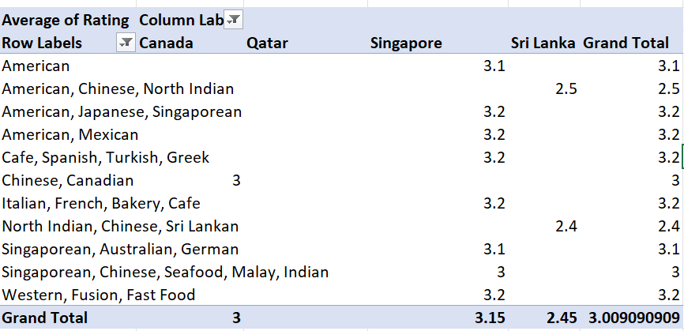

1. According to our current data, should we go for online delivery and table booking? Does that affect the customer’s ratings?

Ans.

**Approach**

* Made two pivot tables
* Table booking in Rows and rating in values . Changed field settings to Average
* Online delivery in Rows and rating in values . Changed field settings to Average

|  |  |  |  |
| --- | --- | --- | --- |
| **Table Booking** | **Average of Rating** |  |  |
|  |  |  |  |
| No | 2.8 |  |  |
| Yes | 3.5 |  |  |

|  |  |
| --- | --- |
| **Online Delivery** | **Average of Rating** |
| No | 2.8 |
| Yes | 3.3 |
|  |  |

* Opting for both **online delivery and table booking** services is a favorable strategy since restaurants offering both tend to have higher average ratings, indicating a positive impact on customer satisfaction.
* We analyzed this by creating two pivot tables — one for **Table Booking** and another for **Online Delivery** — comparing average ratings under both **Yes** and **No** scenarios.

**Sheet Subjective questions**

1. Should the team keep the rate of cuisines higher? Will that affect the feedback? According to our data are the rates of cuisines and ratings, correlated?

Ans. **Approach**

* Made a pivot table
* Pivot Table→Cuisine in Rows → Average Rating and Average of Cost in INR in Values.
* Derived Correlation using =CORREL(B174:B206,C174:C206)

1. **Positive Correlation:** The correlation between average ratings and the average cost for two is approximately **0.656**, indicating a **moderate to strong positive relationship**. As ratings increase, the average cost for two generally tends to rise.
2. **Low-Cost Restaurants:** Restaurants with ratings between **1 to 3.5** primarily have lower average costs (below **₹1500**). This suggests that budget-friendly eateries may be rated lower due to limited offerings or compromised quality.
3. **Premium Experience:** Higher-rated restaurants (ratings **3.6 to 4.9**) show a sharp increase in the average cost, with many priced above **₹3000**. This implies that customers are likely willing to spend more for better dining experiences.
4. **Potential Opportunity:** Since the cost steadily rises along with better ratings, improving food quality, service, and customer experience for lower-rated budget-friendly restaurants could help increase their ratings and profitability.
5. **Exception Zones:** Some restaurants in the **4.2 to 4.6 range** show fluctuating costs, possibly indicating niche or specialized dining experiences.

* **Sheet subjective questions**

|  |  |
| --- | --- |
| **Row Labels** | **Average of Average_cost_For_two_In_Rs** |
| 2.4 | 522 |
| 2.5 | 580 |
| 3 | 1544.25 |
| 3.1 | 3794 |
| 3.2 | 3902.4 |
| 3.3 | 1462.5 |
| 3.4 | 5406 |
| 3.5 | 435 |
| 3.6 | 1434 |
| 3.7 | 3688.875 |
| 3.8 | 9296.875 |
| 3.9 | 8597.8 |
| 4 | 3514.625 |
| 4.1 | 1645 |
| 4.2 | 1224.333333 |
| 4.3 | 4797 |
| 4.4 | 11440 |
| 4.5 | 4348.5 |
| 4.6 | 6240 |
| 4.7 | 5200 |
| 4.9 | 3180 |

1. What is the distribution of the number of restaurants of different price ranges in all the countries?

Ans.**Approach:**

* Created a Pivot Table with Price Range in rows and Count of RestaurantID in values to analyze the distribution of restaurants across price categories.

**Insights:**

* A significant portion of restaurants (**46% or 4438**) belongs to Price Range 1, indicating that affordable dining options dominate the market.
* Restaurants in Price Range 2 account for **3113 (32%)**, while Price Range 3 has **1405 (15%)** establishments.
* Only **586 (6%)** restaurants fall under Price Range 4, showing that high-cost dining options are limited.
* The data shows a steady decline in the number of restaurants as prices increase, possibly due to limited demand at higher price points.

**Recommendations:**

* Opening restaurants in Price Ranges **1 or 2** would be advantageous to capture a broader customer base, as these segments represent the majority of the market.
* For Price Ranges **3 and 4**, focusing on providing a premium dining experience with high-quality food and exceptional service could help attract a niche clientele willing to spend more for exclusive offerings.
* **Sheet Subjective Questions**

1. Explain your approach in brief for suggesting countries/cities in order to open new restaurants, if the objective and subjective questions would have not been given to assist you. **[you have to give bullet pointers in order to answer this question]**

**Ans. APPROACH:**

**Data Cleaning:**

* Check for missing data in the table, handle the missing values by using mode, average etc.
* Remove any duplicate values.
* Check for any spelling error using filter.

**Preparing the Data:**

* Convert the datekey column into date format using find and replace.
* Add columns like day month year using the datekey column.
* Add a country column based on the country codes given in data.
* Convert the average cost of two in a single currency.

**Analysis:**

* Find countries which have less comptetion by counting the number of restaurants.
* Will also consider the countries which have lower ratings.
* The geographical size of a country will also be considered. For instance, if one country has fewer restaurants but a smaller area, while another has slightly more restaurants but a larger area, the density of restaurants per square kilometer would still be lower in the latter.
* I will check the most loved cuisines for my restaurants.
* Pick the cities in the respective countries which have higher average ratings.
* Check how restaurants have opened up in previous year in the selected countries to know the Competiton/Market slightly better.
* Price of cuisines At our restaurants

**Visualisation:**

* Interpret the analysis above.
* Use different charts to analyse the above for a better understanding
* Use filterin country, price range, year and average cost.

**Conclusion:**

* Write conclusion based on the above interpretation.

**The dashboard must consist of Year-wise and country slicers.**